Steady State dq Model of Torque Controlled Synchronous Machine:
Constraints:
1) Constant Amplitude and Phase of i

i = I_{qs} , i = I_{ds}

2) Constant Rotor Flux

i = 0 , i = 0 (no damper currents)

3) Constant Rotor Field Current

i = I_{f}
0
0
T_{e} = [λ i - λ i] = [(L_{md} I_{f} + L_{md} i + L_{ds} I_{ds}) I_{qs} – (L_{mq} i + L_{qs} I_{qs}) I_{ds}]
λ_{r}

= [L_{md} I_{f} I_{qs} – (L_{ds} – L_{qs}) I_{qs} I_{ds}]
BLI torque
Reluctance torque

v = r_{s} I_{qs} + ω_{r} λ  = r_{s} I_{qs} + ω_{r} [L_{md} I_{f} + L_{ds} I_{ds}]  v = r_{s} I_{qs} – ω_{r} λ  = r_{s} I_{qs} – ω_{r} L_{qs} I_{qs} | 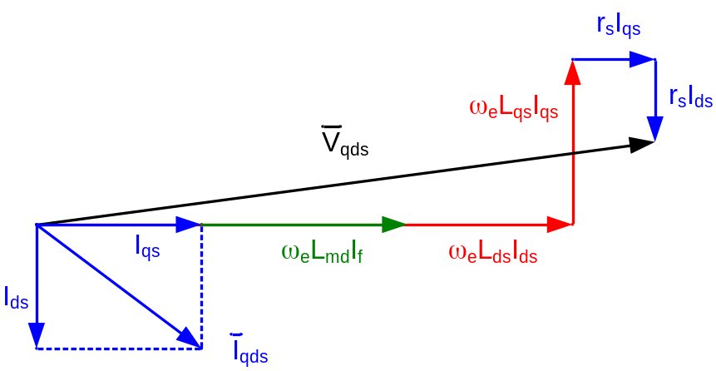
 | Vector Diagram of Steady State Operation of Synch. Motor

Steady State Induction Machine Field Orientation Using dq Model:
Constraints:
1) Independent control of i

i = I_{qs} , i = I_{ds}

2) Orient Reference Frame to Rotor Flux such that i is in direction of Rotor Flux

Rotor Flux Equation:

l = L_{m} i + L_{r} i

λ = L_{m} i + L_{r} i = 0 ← all flux aligned with d-axis

therefore

λ = L_{m} i + L_{r} i = L_{m} I_{ds} + L_{r} I_{dr} ← steady state

Rotor Voltage Equations:
[p + j(ω_{e} – ω_{r})] l + r_{r} i = 0

j(ω_{e} – ω_{r}) l + r_{r} I_{qdr} = 0 ← steady state

λ – j λ I_{qr} – j I_{dr}

(ω_{e} – ω_{r}) λ + r_{r} I_{qr} = 0

–(ω_{e} – ω_{r}) λ + r_{r} I_{dr} = 0 → I_{dr} = 0 (since λ = 0)

therefore

ω_{e} – ω_{r} = I_{qr} = =

ω_{e} – ω_{r} = ← slip relationship for field orientation
rotor time constant

0
T_{e} = Im{i l } = [λ i - λ i] = I_{ds} I_{qs}
torque producing current
field
current

Stator Voltage Equation:
0 for steady state
v = r_{s} i + (p + j ω_{e})l

V_{qds} = r_{s} I_{qds} + j ω_{e} l ← steady state

l = L_{s} I_{qds} + L_{m} I_{qdr}
eliminate I_{qdr}

l = L_{m} I_{qds} + L_{r} I_{qdr}

l = σ L_{s} I_{qds} + l σ = 1 – (coupling factor)

V_{qds} = (r_{s} + j ω_{e} σ L_{s}) I_{qds} + j ω_{e} l

I_{qr} is like the compensating winding in a DC machine | 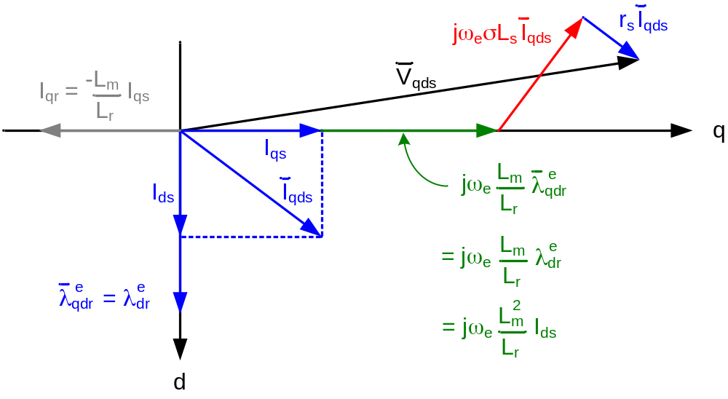
 | Vector Diagram of Steady State Operation of Induction Motor

Steady State Induction Machine Field Orientation:

λ = 0 Comparison to Transient Case

1) I = I ← Same

2) I = 0 ← Only S.S.

3) λ = L_{m} I ← Only S.S.

4) s ω_{e} = = ← Only S.S.

5) T_{e} = λ I ← Same

= I I ← Only S.S.

Dynamic State Induction Machine Field Orientation:
[p + j(ω_{e} – ω_{r})] l + r_{r} i = 0

r_{r} i + p λ + (ω_{e} – ω_{r})λ = 0

r_{r} i + p λ – (ω_{e} – ω_{r})λ = 0

λ = 0 → (same as S.S. condition 1)
λ = L_{m} i + L_{r} i

r_{r} i + s ω_{e} λ = 0 → (not the same as S.S. due to λ)

r_{r} i + p λ = 0

a) Eliminate λ = L_{m} i + L_{r} i

r_{r} i + L_{m} p i + L_{r} p i = 0

(r_{r} + L_{r} p) i = -p L_{m} i

=

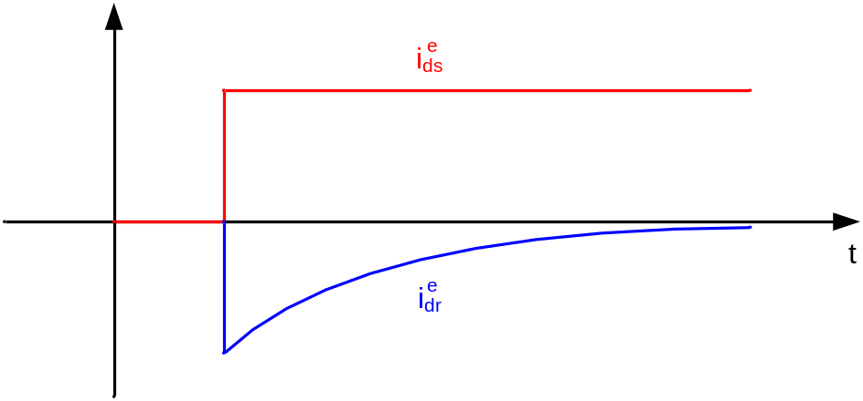
Change in Rotor d-Axis Current with a Change in Stator d-Axis Current

b) Eliminate i = – i

λ – i + p λ = 0

λ = L_{m} i (in S.S. λ = L_{m} I)

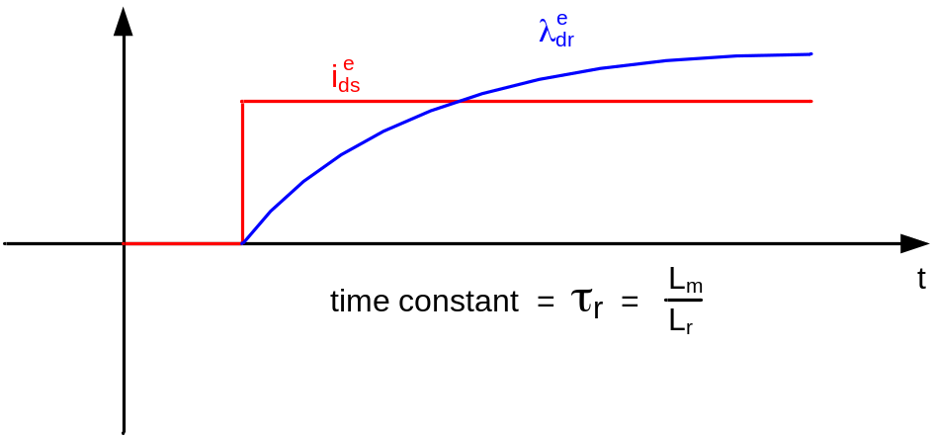
Change in Rotor Flux with a Change in Stator d-Axis Current

Major difference in transient case is that there can be a d-axis rotor current induced by any change in d-axis stator current that is not slip related.

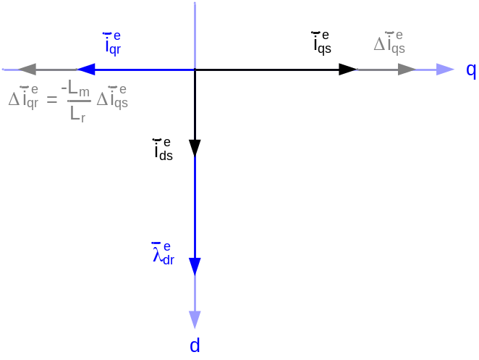 | 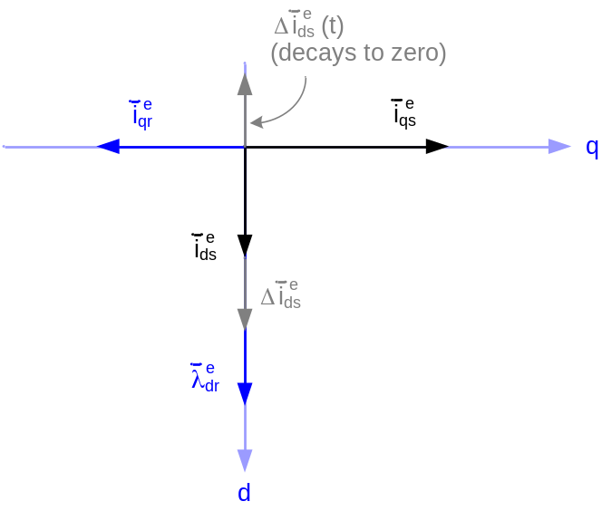

Fully Transient Indirect Field Orientation of Induction Machine with i and i :

λ = i

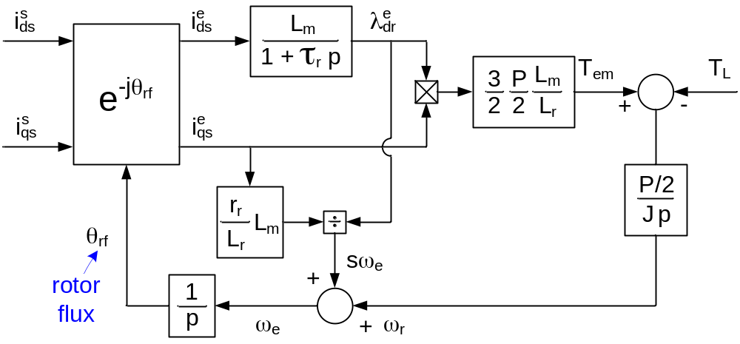
Current Fed Induction Machine in Rotor Flux Oriented Reference Frame

Indirect Field Orientation uses slip relationship to determine rotor flux

Recap: Induction Machine Field Orientation Using dq Model

A static look at Field Orientation in an Induction Machine:

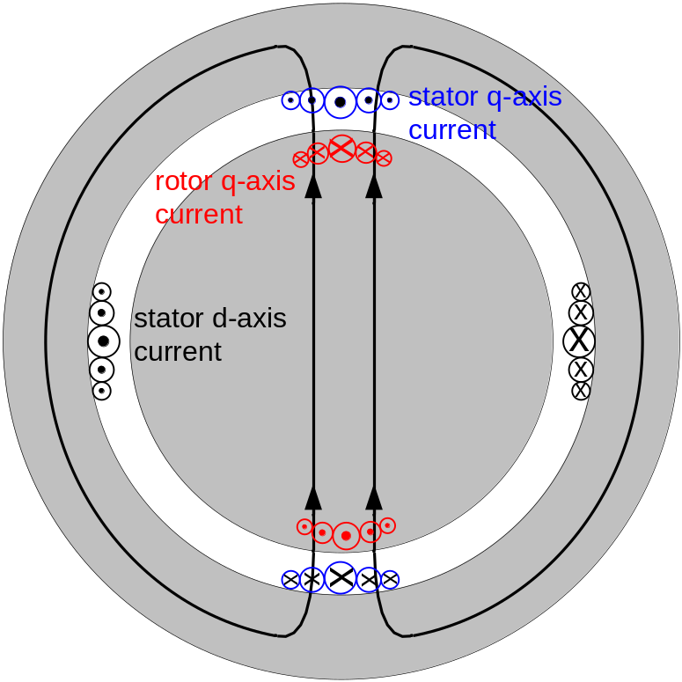 | 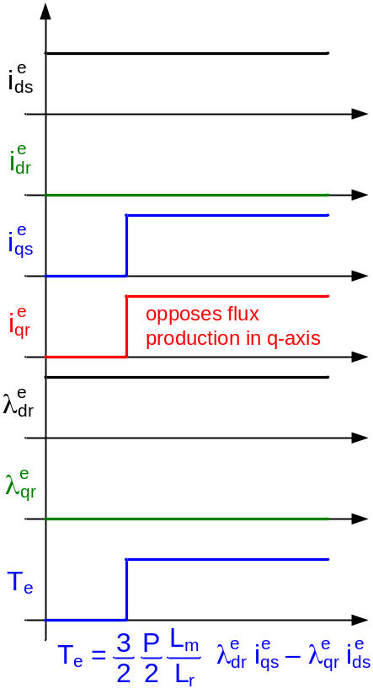  ( )
Torque Production in IM with Steady State d-Axis Current and Sudden Application of q-Axis Current

So far we have discussed Indirect Field Orientation (IFO). IFO uses slip relationship to determine the spatial location of rotor flux.

“Direct” Field Orientation:

Rotor flux angle is “directly” measured (or estimated) rather than calculating it using the slip relationship. The two methods are:

a) Using air gap flux sensors (not common)
l = L_{m} (i + i) → i = – i

l = l + L_{lr} i
= l + l – L_{lr} i
= l – L_{lr} i

Problems
1) Sensors in airgap
2) L_{lr} variations (w/load)

b) Use terminal voltage
l = (v– r_{s} i) integrate stator voltage to get stator flux

l = L_{m} i + L_{r} i

i = – i

→ l = (l – L i) solve for rotor flux from stator flux and current

L = Stator Transient Inductance
~ 0

L = L_{s} – ~ L_{ls} + L_{lr} L = L_{ls} + L_{lr} –

Two Methods of Field Oriented Control (FOC) :

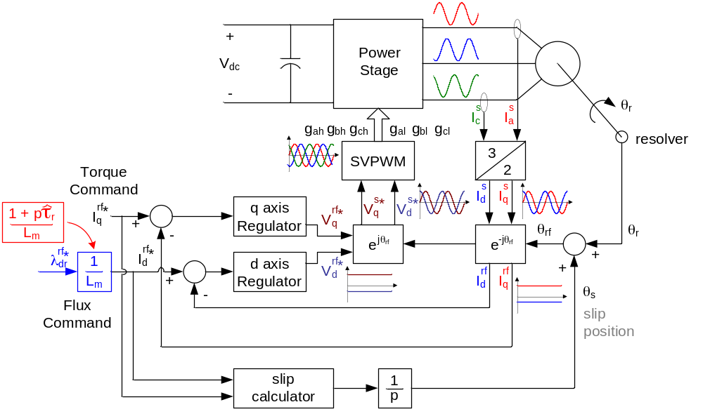
Indirect Field Orientation – Rotor Flux Orientation Induction Machine Control

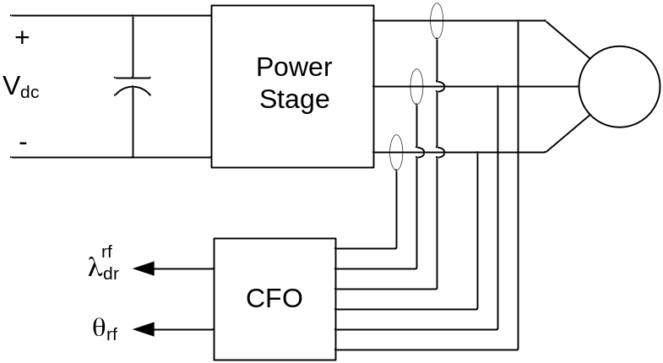

Tan⁻¹(l)

Direct Field Orientation – Rotor Flux Orientation Induction Machine Control

Current Regulation in DC Machines:

For speed control in DC machines, we don’t need to close a current loop. However, it is a preferred method for high performance motor controls. Closed loop speed can be controlled without a current loop. Assuming a speed control with an ideal voltage source using voltage as the manipulated variable, we have the following block diagram.

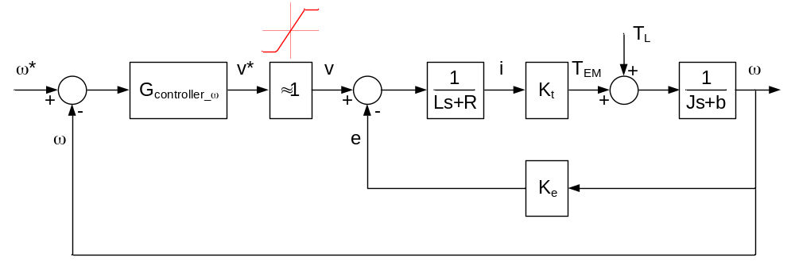
Speed Control of a DC Motor with Voltage as the Manipulated Variable

=

Difficult to design & tune G_{c} to get desired results. Alternative approach, control current with inner current loop.

Use Proportional plus Integral (PI) Control

G_{c} = K_{p} + = =

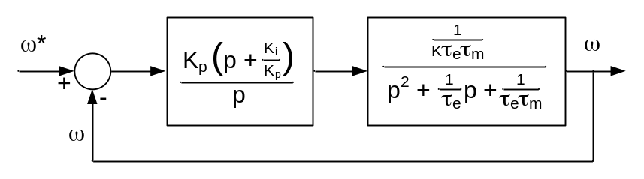
Speed Control of a DC Motor with Voltage as the Manipulated Variable with PI Controller

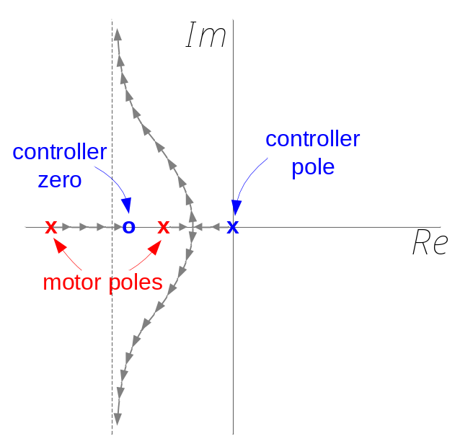 | 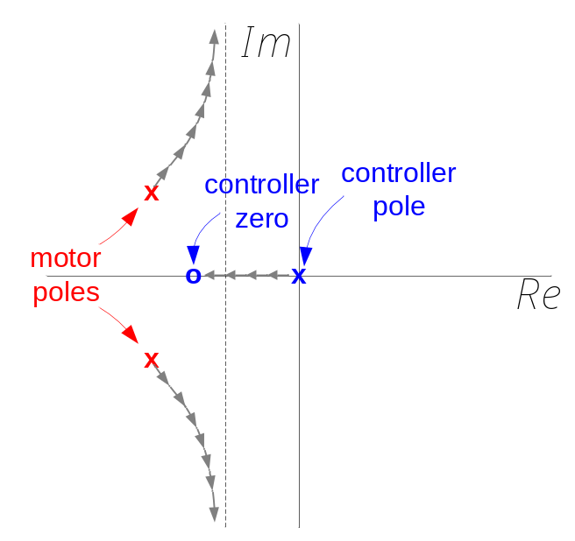
Small Motor | Large Motor
Root Locus of DC Motor with PI Speed Controller

Closed Loop Speed Control Via Closed Loop Current Control

Closed loop speed control with ideal voltage source using voltage as manipulated variable with an inner current loop.

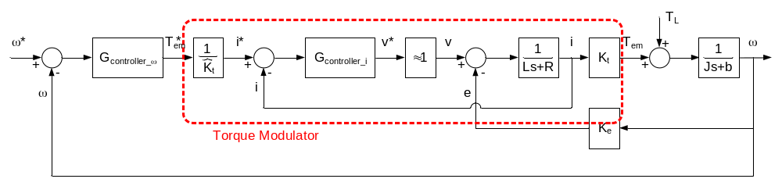
Speed Control of a DC Motor with Voltage as the Manipulated Variable

If current regulation is robust and significantly higher bandwidth than the desired rate loop dynamics, then we can assume that the current loop is ideal (i.e. actual current = commanded current).

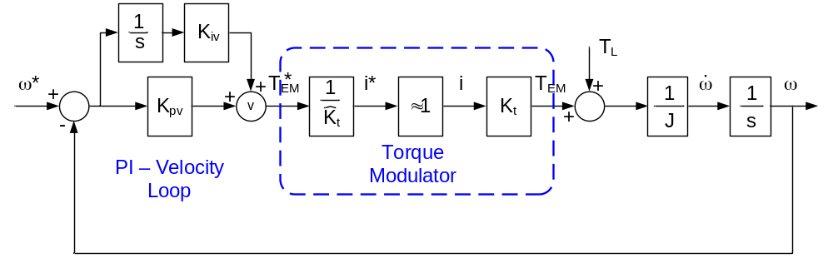
Speed Control of a DC Motor with Voltage as the Manipulated Variable

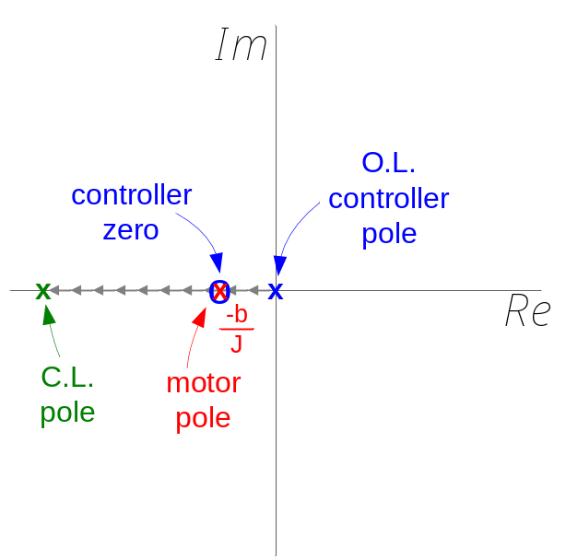
Root Locus of DC Motor with PI Speed Controller with Ideal Inner Current (Torque) Loop

Response not limited by τ_{e} and τ_{m}.

Only limited by feasible gains, system saturations.
(limited by noise) (voltage/current limits)

Current Loop Closure in DC Machines:

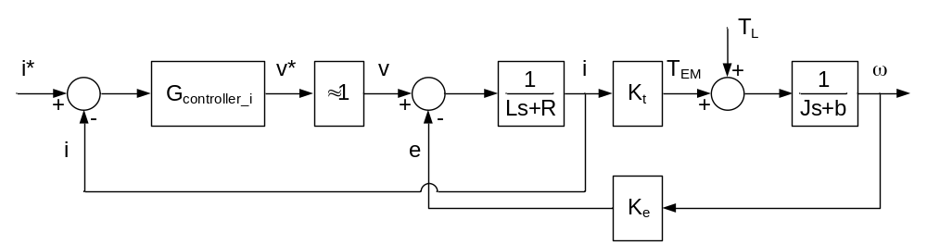
Current Regulator for DC Motor

Industry Standard is to use a Proportional Plus Integral (PI) Controller as shown below:

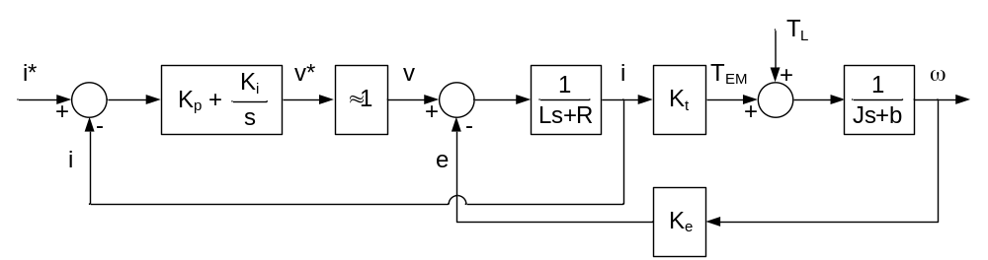
PI Current Regulator for DC Motor

Transfer function for current regulator:

=

The challenge is how to tune current regulator gains, namely, how should we select K_{p} and K_{i}? The answer is:

Tune current loop at locked rotor to decouple the effects of Back EMF:

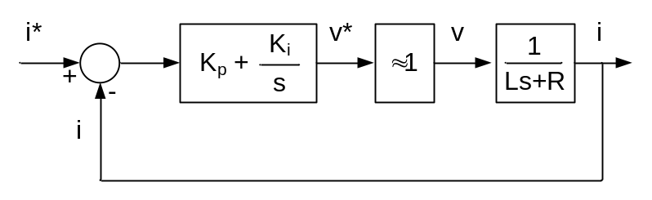
PI Current Regulator for DC Motor

Which can be redrawn as:

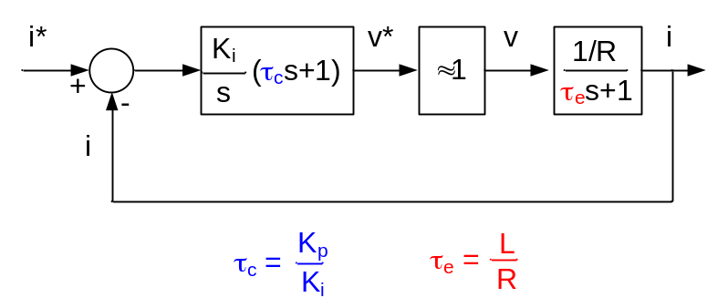
PI Current Regulator for DC Motor Expressed as Time Constants

If τ_{c} = τ_{e}:

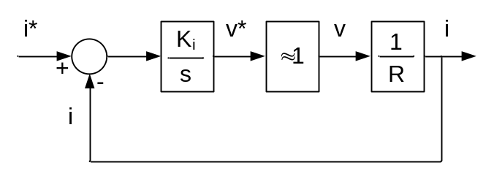
PI Current Regulator for DC Motor with Exact Pole-Zero Cancellation

The transfer function becomes:

= where K_{tot} =

To determine bandwidth, set K_{tot} = 2πf_{desired}

where f_{desired} = desired bandwidth in hertz.

Therefore, the gains to tune the current loop at locked rotor conditions are:

and

Note: By using Back EMF decoupling, the desired bandwidth can be achieved at no zero speed conditions as well.

AC Current Regulation:

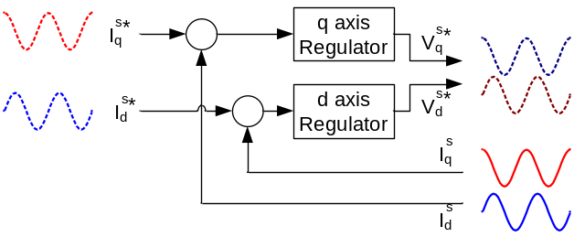 | 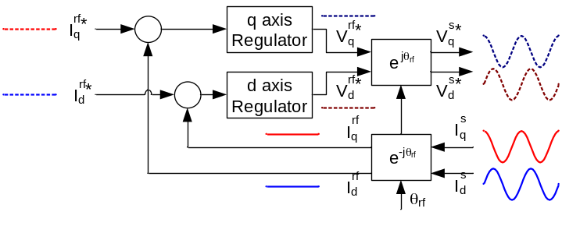
AC Current Regulation (Stationary Reference Frame – Left, Synchronous Reference Frame – Right)

PowerPoint Slideshow on Current Regulator Tuning.

